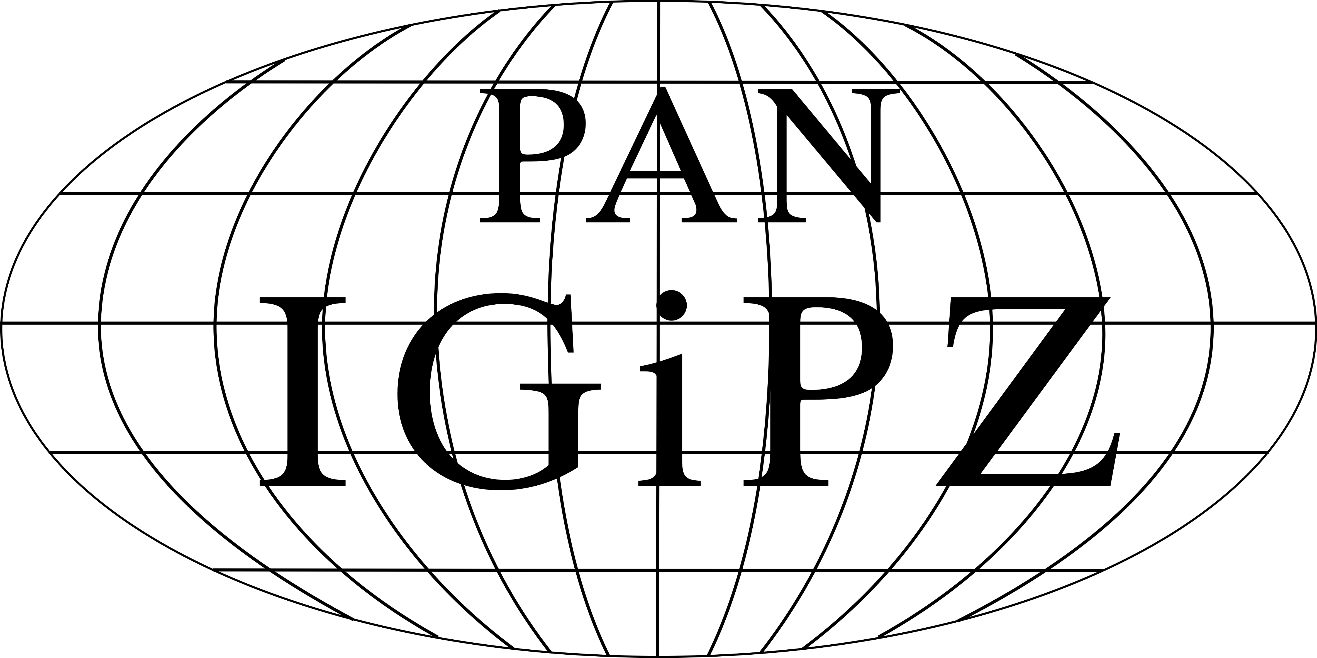 | 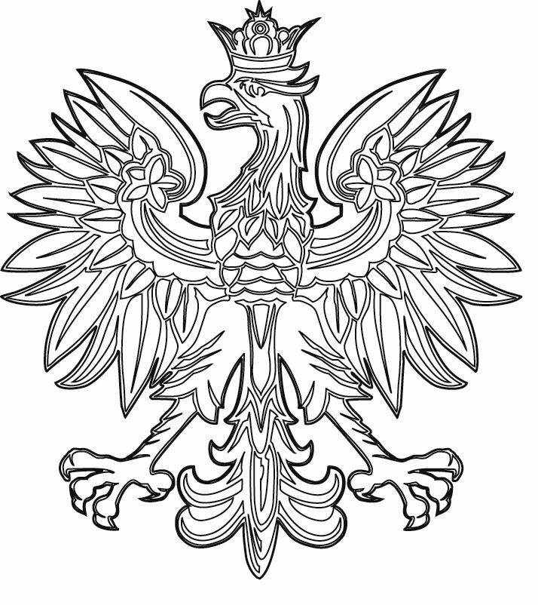 |  | 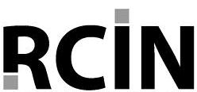

WARSAW REGIONAL FORUM 2013

Territorial capital – concepts, indicators & policy

Warsaw, 8-12 October 2013

organized by:

Institute of Geography and Spatial Organization, Polish Academy of Sciences
Ministry of Regional Development, Republic of Poland
Polish Geographical Society
Digital Repository of Scientific Institutes

REGISTRATION FORM

Surname: First name:

Professional Institution:

title:

Mailing Country:

address:

Phone: E-mail address:

Information for preparing the receipt
/Institution, address, NIP number/:

Intend to present a paper YES NO

Title:

Intend to participate in the study tour (8-9.10.2013) – cost 150 €

YES NO

Please return the form before 31st July 2013 (with presentation) or 30th September 2013 to: forum@igipz.pan.pl

