 | 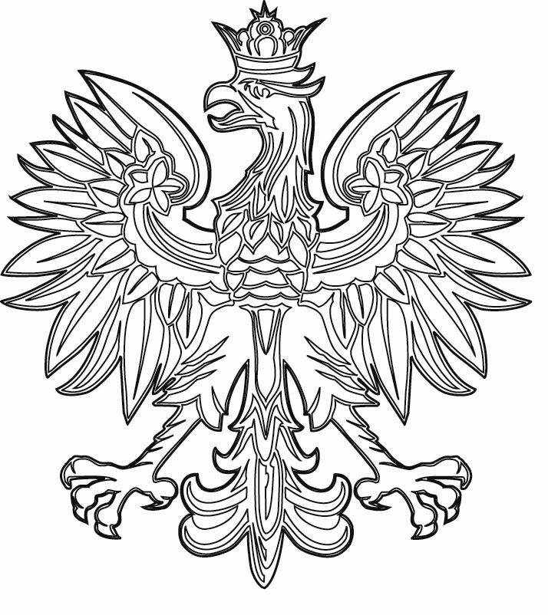 | 

WARSAW REGIONAL FORUM 2017

Space of flows

Warsaw, 18-20 October 2017

REGISTRATION FORM

Surname: First name:

Professional Institution:

title:

Mailing Country:

address:

Phone: E-mail address:

Information for preparing the receipt
/Institution, address, NIP number/:

Intend to present a paper: YES NO Intend to present a poster: YES NO

Title:

Intend to participate in the study tour (18.10.2017) – free of charge

YES NO

Please return the form before 31st July 2017 (with presentation) or 30th September 2017 to: forum@igipz.pan.pl

